Riding Mechanic: Requirements Document (version 3.0)

Project: Riding Mechanic: An iOS App for Vehicle Monitoring and Analysis
Date(s): 9/19/2016
Prepared by: Dezheng Wang
Advisor: Dr. Elliott Forbes
Document status: _ Draft _Proposed √ Validated _ Approved

1. Introduction
This document contains the system requirements for Riding Mechanic. These requirements have been derived from several sources, including end-users, project advisor and developer.

1.1 Purpose of This Document
This document is intended to guide development of Riding Mechanic. It will go through several stages during the course of the project:
- Draft: The first version, or draft version, is compiled after requirements have been discovered, recorded, classified, and prioritized.
- Proposed: The draft document is then proposed as a potential requirements specification for the project. The proposed document should be reviewed by several parties, who may comment on any requirements and any priorities, either to agree, to disagree, or to identify missing requirements. Readers include end-users, developers, project managers, and any other stakeholders. The document may be amended and reproposed several times before moving to the next stage.
- Validated: Once the various stakeholders have agreed to the requirements in the document, it is considered validated.
- Approved: The validated document is accepted by representatives of each party of stakeholders as an appropriate statement of requirements for the project. The developers then use the requirements document as a guide to implementation and to check the progress of the project as it develops.

1.2 How to Use This Document
We expect that this document will be used by people with different skill sets. This section explains which parts of this document should be reviewed by various types of readers.

Types of Reader
End-users who may have some modifications to requirements. Project advisor who will give advices to this requirements document. Developer who will design the app through this document.
Technical Background Required
End-uses don’t need to have any knowledge about the design. Project advisor and developer should be familiar with software development.

1.3 Scope of the Product
This product is an iOS based application. Users should install this app on their iphone and start to use it when the OBDII adapter is connected to the car. This app can only be used to read and analyze data from cars and to display useful informations.

1.4 Overview of the Requirements Document
The app should be used to monitor a vehicle’s operation and discover potential concerns before they become serious faults. The app can identify the effect certain configuration changes have on a car’s operation throgh route analysis.

2. General Description
This section will give the reader an overview of the project, including why it was conceived, what it will do when complete, and the types of people we expect will use it. We also list constraints that were faced during development and assumptions we made about how we would proceed.

2.1 Product Perspective
With people paying more attention to their own vehicals, car diagnostic applications become more and more inportant. Common users can check and maintain their cars according to the application. I’m th primary stakeholders and I’m developing the project. The end-users will benefit from the finished product.

2.2 Product Functions
This product has two main functions. The first one is to detect potential problems in the car and report to user. The conclusion form the app is reliable because all the data are from the ECU in the car. The second one is to help users identify the effect certain configuration changes have on a car’s operation throgh route analysis. Users can clearly see all kinds of informations of the car in the app. Such as average speed and average MPG(miles per gallon). As for the other functions, users can register and then users accounts will be stored in the database. Only users login can their cars’ informations stay with their accounts.

2.3 General Constraints
This product is an iOS based application in iphone. I plan to use my mac(Version 10.10.5) for development and testing. The integrated development environment is Xcode(Version 7.2.1). When you want to resigster an user account, you need to provide your email and then verify it in correspoding email.

2.4 Assumptions and Dependencies
The finished product will not be delivered over the internet. But it will be tested by some iphone users. In my project, I plan to use local database becase this project is small to medium in size.
There will exist database administrators to manage user accounts.

3. Specific Requirements
This section of the document lists specific requirements for Riding Mechanic. Requirements are divided into the following sections:
- User requirements. These are requirements written from the point of view of end-users, usually expressed in narrative form.
- System requirements. These are detailed specifications describing the functions the system must be capable of doing.
- Interface requirements. These are requirements about the user interface, which may be expressed as a list, as a narrative, or as images of screen mock-ups.

3.1 User Requirements
Index: Access_Login
Name: Login
Purpose: To login to the system
Input parameters: Username(email address), password
Action: Ensure that Username exists in the system.
Ensure that Username and Password match with the corresponding entries stored in the database.
If they match, set the status of the user as logged in, and let the user perform other activities.
Output parameters: None
Exceptions: Username does not exist.
Username and Password do not match with the stored entries.
Remarks: Designer may want to check the format of inputs before validating them and input validation.
Cross-references: None

Index: Access_Logout
Name: Logout
Purpose: To logout from the system
Input parameters: None
Action: Ensure that the user has already logged in.
Set the status of the user as logged out and ensure that the user does not have access to the system.
Terminate all pending activities.
Output parameters: None
Exceptions: User doesn’t login.
Remarks: None
Cross-references: None

Index: Access_Register
Name: Register
Purpose: To register for the system
Input parameters: Full name, username(email address), password
Action: Ensure that the user hasn’t registered before.
User enters all necessary information and then submit.
Output parameters: None
Exceptions: Username has been added into the system.
Remarks: None
Cross-references: None

Index: Access_ForgetPassword
Name: Forget password
Purpose: To get password with corresponding username(email address).
Input parameters: Username(email address).
Action: Ensure that the username is valid.
The password mathed with username(email address) will be sent to mailbox.
Output parameters: password
Exceptions: Username doesn’t exist.
Enter wrong username.
Remarks: None
Cross-references: None

Index: Function_ChooseCarModel
Name: Choose car model
Purpose: To choose correct car model
Input parameters: None
Action: Ensure that user has already logged in.
Choose car brand first and then choose specific model.
Output parameters: None
Exceptions: User doesn’t login.
User can’t find the car model in cars list.
Remarks: None
Cross-references: None

Index: Function_ChooseAvatar
Name: Choose avatar
Purpose: To choose avatar
Input parameters: image
Action: Ensure that user has already logged in.
Choose avatar from photos in the phone.
Output parameters: None
Exceptions: User doesn’t login.
Remarks: None
Cross-references: None

Index: Function_StartConnecting
Name: Start connecting
Purpose: To connect phone to OBDII adapter.
Input parameters: None
Action: Ensure that user has already logged in.
Ensure that status of connection is not connected.
Ensure that OBDII adapter is connected to the car’s OBDII port.
Ensure that the phone is connceted to OBDII adapter’s wifi.
Start connecting
Output parameters: Status of connection
Exceptions: User doesn’t login.
Status of connection is connected.
OBDII adapter isn’ connected to the car’s OBDII port.
Phone isn’t connceted to OBDII adapter’s wifi.
Remarks: None
Cross-references: None

Index: Function_StartTrip
Name: Start trip
Purpose: To record a trip.
Input parameters: None
Action: Ensure that user has already logged in.
Ensure that status of connection is connected.
Start recording a trip
Output parameters: List of car’s information
Exceptions: User doesn’t login.
Status of connection is not connected.
Remarks: None
Cross-references: Function_StartConnecting

Index: Function_AnalyzeRoute
Name: Analyze route
Purpose: To analyze route.
Input parameters: None
Action: Ensure that user has already logged in.
Ensure that status of connection is connected
Ensure that user has recorded some trips before.
Start analysizing route.
Output parameters: List of car’s information
Exceptions: User doesn’t login.
Status of connection is not connected.
User hasn’t recorded any trips before.
Remarks: If user hasn’t recorded any trips before, system will give some prompt.
Cross-references: Function_ StartTrip

Index: Function_CheckHealth
Name: Check health
Purpose: To check the car’s health
Input parameters: None
Action: Ensure that user has already logged in.
Ensure that status of connection is connected
Start checking health.
Output parameters: List of car’s default code
Exceptions: User doesn’t login.
Status of connection is not connected.
The defalut code is not available in the database.
Remarks: If car doesn’t have any problems, it will display some message instead of default code.
Cross-references: None

Index: Function_EditProfiles
Name: Edit profile
Purpose: To edit profiles
Input parameters: Personal info
Action: Ensure that user has already logged in.
Start editing profiles
Output parameters: None
Exceptions: User doesn’t login.
Remarks: None
Cross-references: None
3.2 System Requirements
3.2.1 OBDII adapter
There is a huge difference between a basic code reader and a full-fledged scan tool. Basic code reader is to read for “generic” diagnostic trouble codes, otherwise full-fledged scan tool is to read both “generic” and OEM” or “enhanced” codes that are vehicle specific. A code reader can provide an inexpensive means of reading and clearing codes, and maybe even checking the status of the OBD II monitors, but that’s all. To read sensor data, history codes, pending codes, etc., you need a “real” scan tool, and the price jumps accordingly. An entry level scan tool with these features starts around $200 and goes up from there. In this project, a basic code reader is remcommended to use with this applicaiton.

3.3 Interface Requirements
UI is an important part of any software or hardware. A software is widely accepted if it is-
- attractive
- easy-to use and easy-to-understand
- consistent and unambiguous
- provide as much help as possible
- provide commands and menus in the same terminology as the user currently uses or the user is familiar with
- provide meaningful error messages
- separated from the application domain so that it should be relatively easier to change the UI without changing the application
User interface requirements are briefly mentioned below –

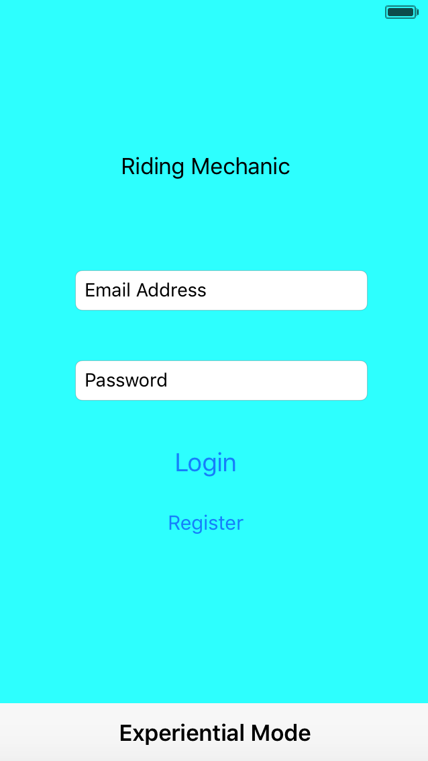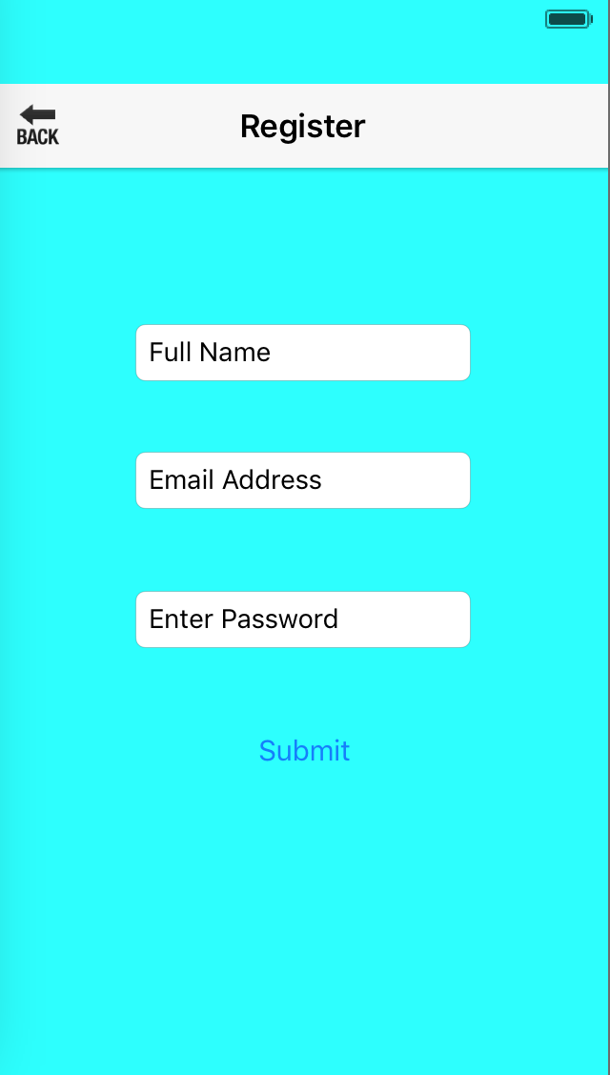
Figure 1:Login Figure 2:Register

Figure 1 describes login screen. The login scrren is also the first look of this app. Valid account includes both email address and password. User can also register for an account in this screen. Experiential mode is that user can experience this app without registering. Some fuctions will not be performed. Figure 2 is the register screen. User can register for his or her own account by using full name, email address and password.

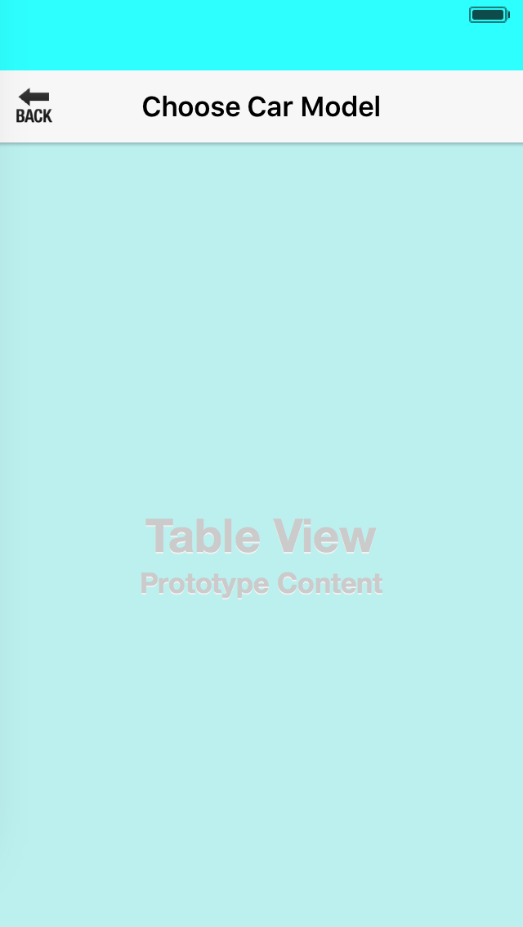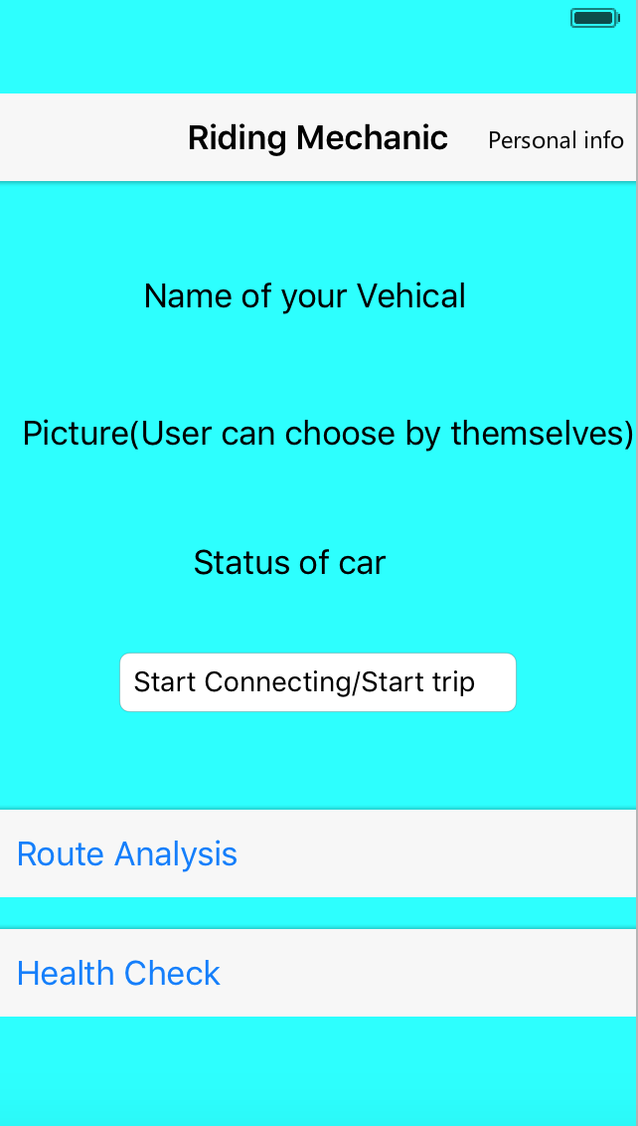
Figure 3: ChooseModel Figure 4: Main

Figure 3 is choosing car model screen. It will show after user registers successfully. The car models will show in list. Figure 4 is main screen. If you are first time user, you will see it after choosing car model. Otherwise, you will see it after login. In this part, user can check their account information, upload pictures as their features, check status of cat, start connecting, start trip, analysis routes and do health check.

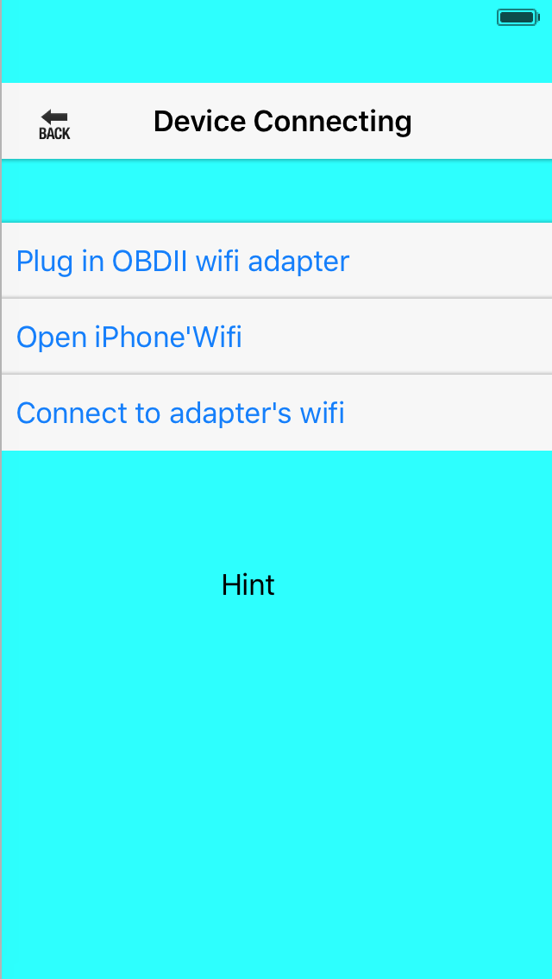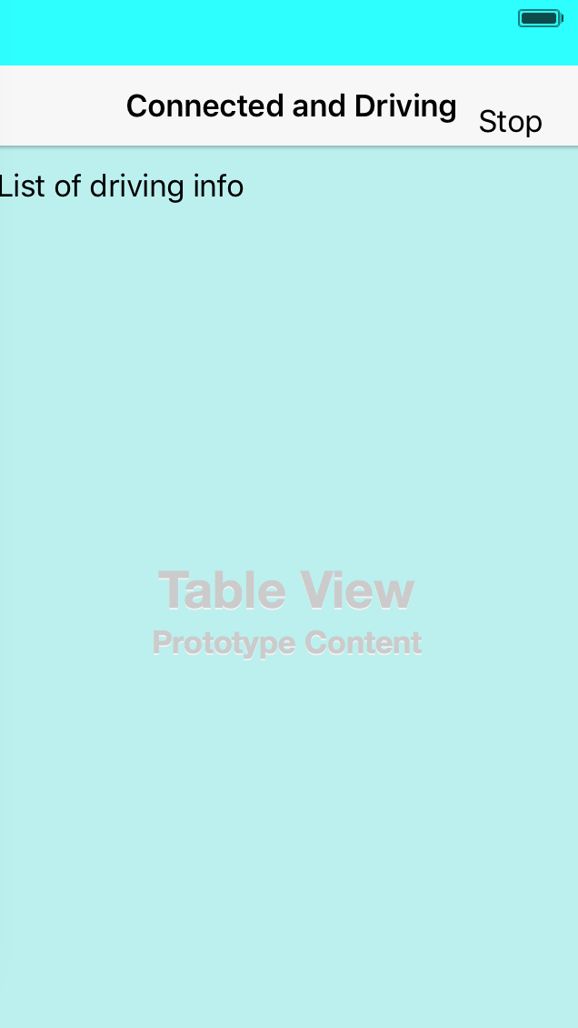
Figure 5: Start connecting Figure 6: Start trip

Figure 5 is starting connecting screen. It will occur after user chooses “start connecting” in main screen. This part will teach user how to connect car with iPone and step by step. Figure 6 is starting trip screen. If status is “connected” in main screen, user can click “start trip” and this screen will occur and display user’s driving information in list format.

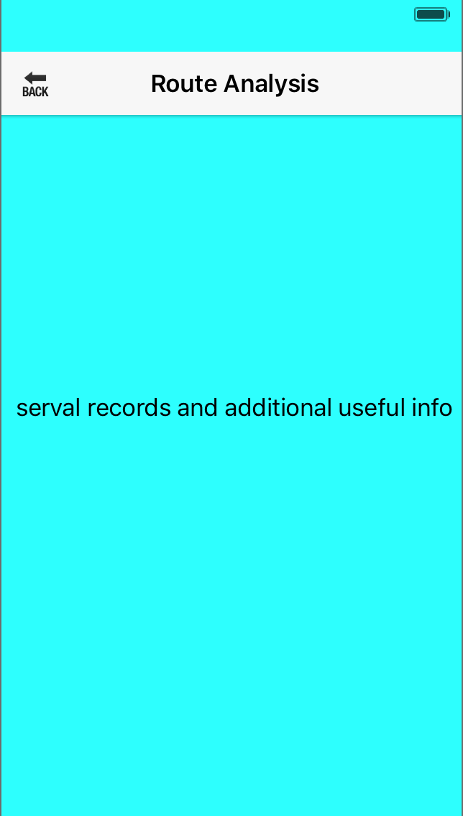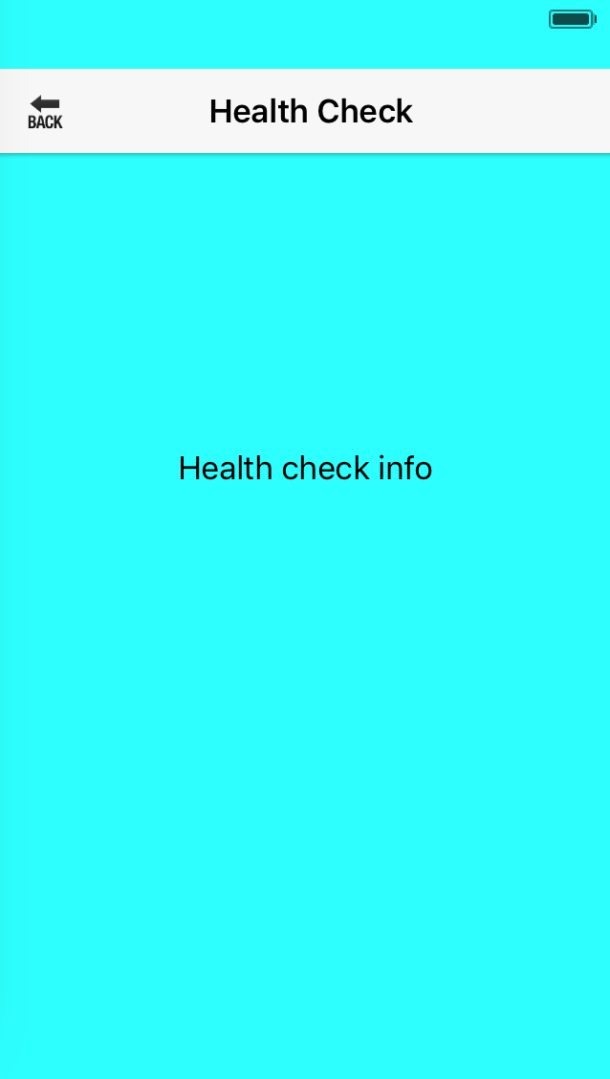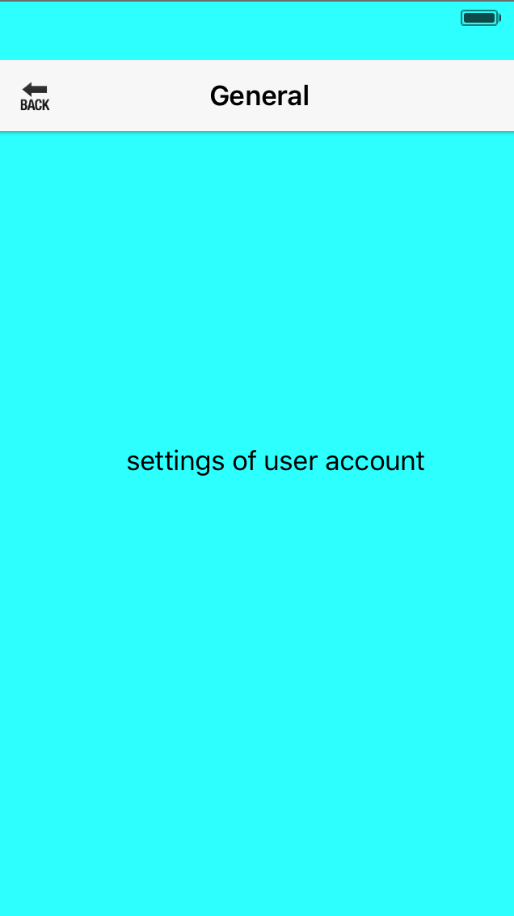
Figure 7: Rout analysis Figure 8:Health check Figure 9: Personal info

Figure 7 discribes rout analysis and the app will display it after user chooses “rout analysis” in main screen. Driving records can be discovered in this part. Additional useful information will be included. Figure 8 is health checking screen. User can do health checking by using this function and car faults will be given if there exist exceptions in your car. Figure 9 is personal information screen. It will appear after user clicks “Personal info” in main screen. In this interface, user can change account information, change vehicle information and log out.

4. Appendices

5. Glossary

6. References

